Central African Republic

## GNI per capita and development level

The data set shows the GNI per capita and development level of the country each year.

## # A tibble: 19 x 5  
## country iso3c date GNIperCapita devCategory   
## <chr> <chr> <dbl> <dbl> <chr>   
## 1 Central African Republic CAF 1996 2076. Lower Middle Income  
## 2 Central African Republic CAF 1998 921. Low Income   
## 3 Central African Republic CAF 2000 946. Low Income   
## 4 Central African Republic CAF 2002 530. Low Income   
## 5 Central African Republic CAF 2003 982. Low Income   
## 6 Central African Republic CAF 2004 526. Low Income   
## 7 Central African Republic CAF 2005 526. Low Income   
## 8 Central African Republic CAF 2006 526. Low Income   
## 9 Central African Republic CAF 2007 537. Low Income   
## 10 Central African Republic CAF 2008 1036. Lower Middle Income  
## 11 Central African Republic CAF 2009 471. Low Income   
## 12 Central African Republic CAF 2010 491. Low Income   
## 13 Central African Republic CAF 2011 507. Low Income   
## 14 Central African Republic CAF 2012 531. Low Income   
## 15 Central African Republic CAF 2013 338. Low Income   
## 16 Central African Republic CAF 2014 337. Low Income   
## 17 Central African Republic CAF 2015 350. Low Income   
## 18 Central African Republic CAF 2016 364. Low Income   
## 19 Central African Republic CAF 2017 386. Low Income

## GDP growth and economic growth classification

The data set shows the GDP growth and the ecomic growth classification of the country each year.

## # A tibble: 19 x 5  
## country iso3c date GDPannualGrowthRate GDPgrowthCategory4  
## <chr> <chr> <dbl> <dbl> <fct>   
## 1 Central African Republic CAF 1996 -4.00 negative grwoth   
## 2 Central African Republic CAF 1998 4.70 moderate growth   
## 3 Central African Republic CAF 2000 -2.49 negative grwoth   
## 4 Central African Republic CAF 2002 3.62 moderate growth   
## 5 Central African Republic CAF 2003 -5.40 negative grwoth   
## 6 Central African Republic CAF 2004 5.99 fast growth   
## 7 Central African Republic CAF 2005 0.908 slow growth   
## 8 Central African Republic CAF 2006 4.77 moderate growth   
## 9 Central African Republic CAF 2007 4.61 moderate growth   
## 10 Central African Republic CAF 2008 2.05 slow growth   
## 11 Central African Republic CAF 2009 8.59 fast growth   
## 12 Central African Republic CAF 2010 4.63 moderate growth   
## 13 Central African Republic CAF 2011 4.19 moderate growth   
## 14 Central African Republic CAF 2012 5.05 moderate growth   
## 15 Central African Republic CAF 2013 -36.4 negative grwoth   
## 16 Central African Republic CAF 2014 0.0811 slow growth   
## 17 Central African Republic CAF 2015 4.34 moderate growth   
## 18 Central African Republic CAF 2016 4.75 moderate growth   
## 19 Central African Republic CAF 2017 4.53 moderate growth

## Development trend

The plot shows the development trend of the country.

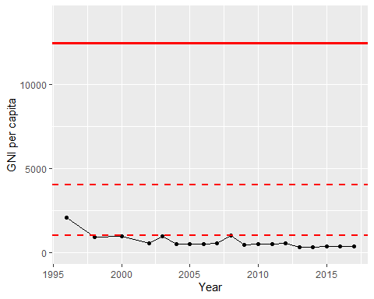

GNI Per Capita Trend